Good day Ann,

The project is already over 60% completed, below are the modules we need to confirm its functionalities before we continue, we think they are the critical part of the entire system. Before we publish for review, we would like to get clarification on them:

* **Receive Help**
  + Make Request
  + Payment Confirmation
  + Request History
  + Payment History
  + Write a Testimony
* **Provide Help**
  + New Donation
  + Make Payment
  + Transaction History
  + All Payments

I noticed in gethelpworldwide.com, before a user is able to make new donation in **Provide Help > New Donation** the user must first add account details in **My Account > Account Detail.**

I also noticed that 30% of donated amount is given within a period of 30 days plus a certain fixed or percentage of bonus. See the screenshot below:

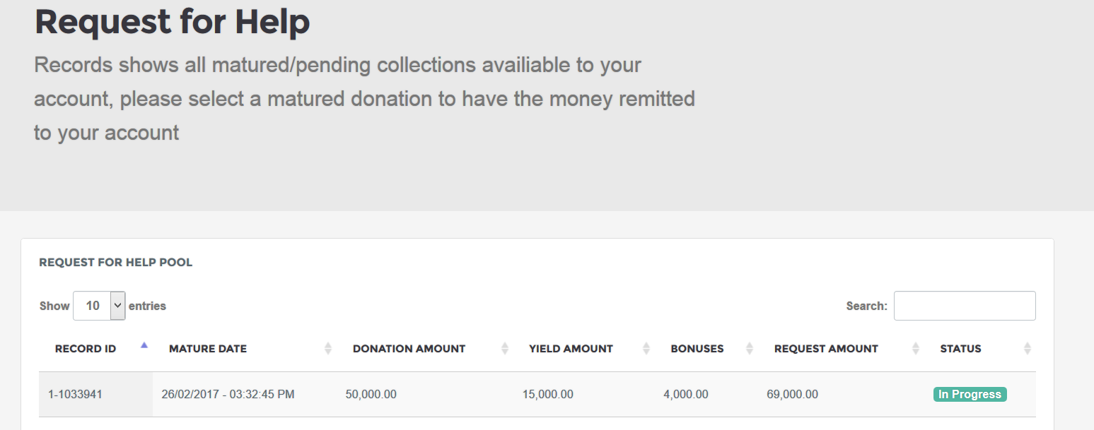

The above screenshot is a demo Donation made**. Matured date:** *IN 30 DAYS*, **Donation Amount:** *50,000*, **Yield Amount:** *30% (i:e 15,000)*, etc.

**Questions**

***Receive Help Module*:**

1. **Receive Help > Make Request:** 
   1. What criteria do you want this section to meet to be able to **Make Request** for help?
2. **Receive Help > Payment Confirmation:** 
   1. What criteria need to meet before record is displayed here?
3. **Receive Help > Request History:**
   1. Please give brief information on how you want this section to display record based on user request?
4. **Receive Help > Payment History:**
   1. Please give brief information on how you want this section to display record based on user payment?
5. **Receive Help > Write Testimony:**
   1. Please tell us how you want users to give testimony?

***Provide Help Module*:**

1. ***Provide* Help > New Donation:** 
   1. According to gethelpworldwide.com, 30% of donated amount is given to the donor in 30 days period plus bonus; do you want yours calculated the same?
   2. If yes, how many percentages of donated amounts you want to give as bonus or do you give fixed amount as bonus? Please explain.
2. ***Provide* Help > Make Payment:** 
   1. Please give us information on how you want this section to perform.
3. ***Provide* Help > Transaction** **History:**
   1. We noticed when **new donation** is made, the record displayed in the section automatically, if this is correct please how do you want the **credibility score** calculated?
4. ***Provide* Help > All Payments:**
   1. Please give brief information on how you want this section to display record based on user payments?

**Note:** *Though we are not familiar with the system (that is, your reference site gethelpworldwide.com), but with your answer to the above questions and detailed explanation we will be able to give you excellent performing system.*